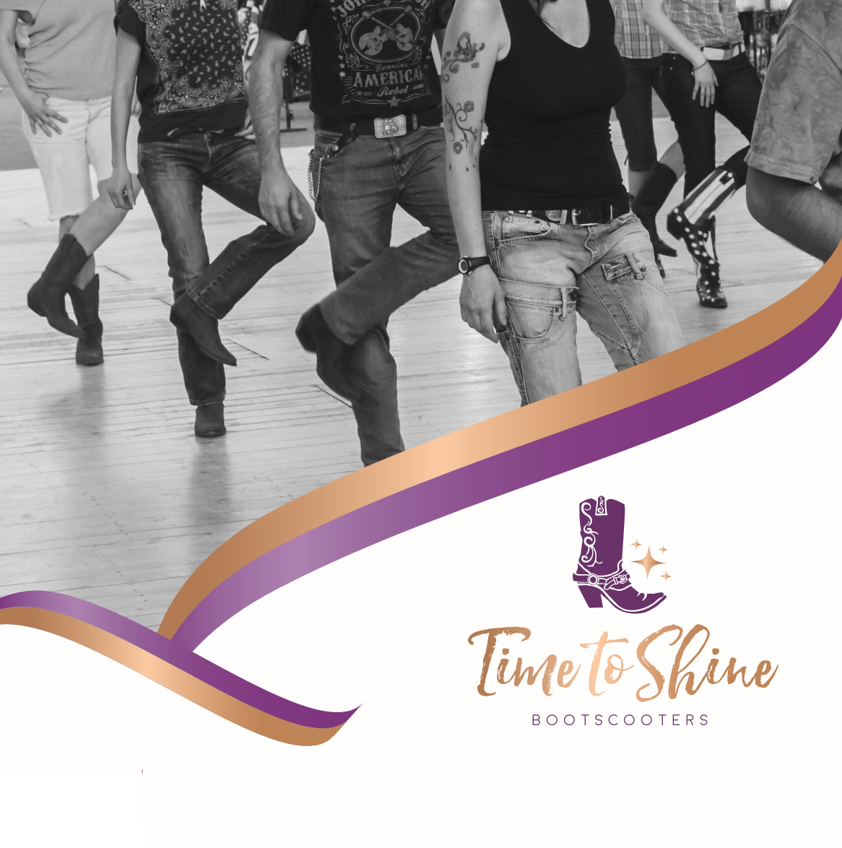
Geelong Line Dancing Classes

Fridays @ The Geelong Ballroom

Dance Club,

Corner of Carey St & Bayview Pde,

Hamlyn Heights
Class time: 9:30 am til 12:30pm
Levels :Absolute Beginners to Easy Intermediates
Entry $12. I provide tea & coffee.
You bring your cup and water bottle.
Contact: Gwendolyn 0408.311.836
New people always welcome, no need to book.

Gwendolyn Morgan-Gibson
0408.311.836
@timetoshinebootscootersclub

